**Practical: 3**

**Aim: Installation and Configuration of Hosted Based Hypervisor (VMware / Oracle virtual BOX).**

1. Download Oracle virtual box from this link: - <https://www.virtualbox.org/wiki/Downloads> after downloaded it just run the virtual box executable file and click “Next”.

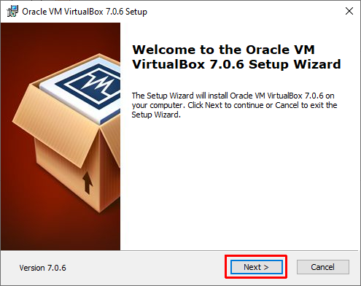

1. Select you installation folder and click “Next”

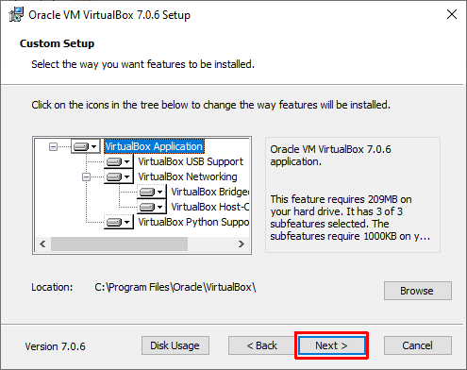

1. Click “Yes”.

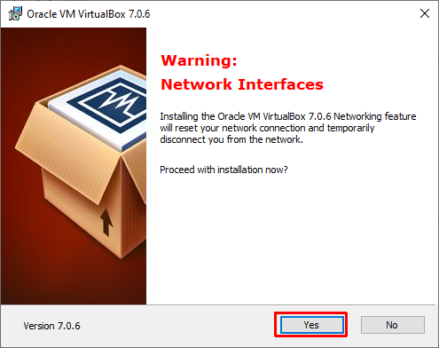

1. Click “Yes”.

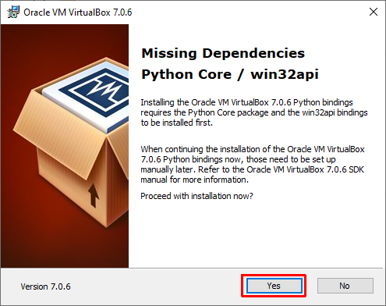

1. Now Just click on “Install” and wait until complete installation process. After installation done click “Finish”.

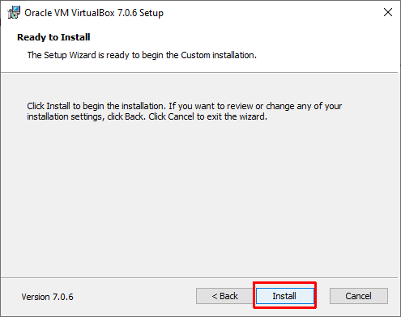

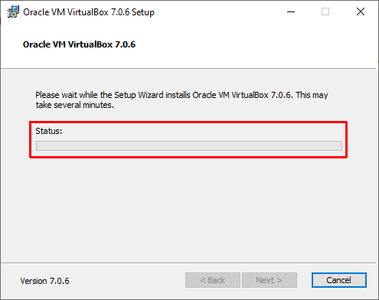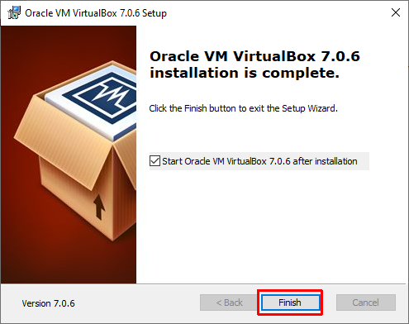

1. Open Virtual box and click on “New”.

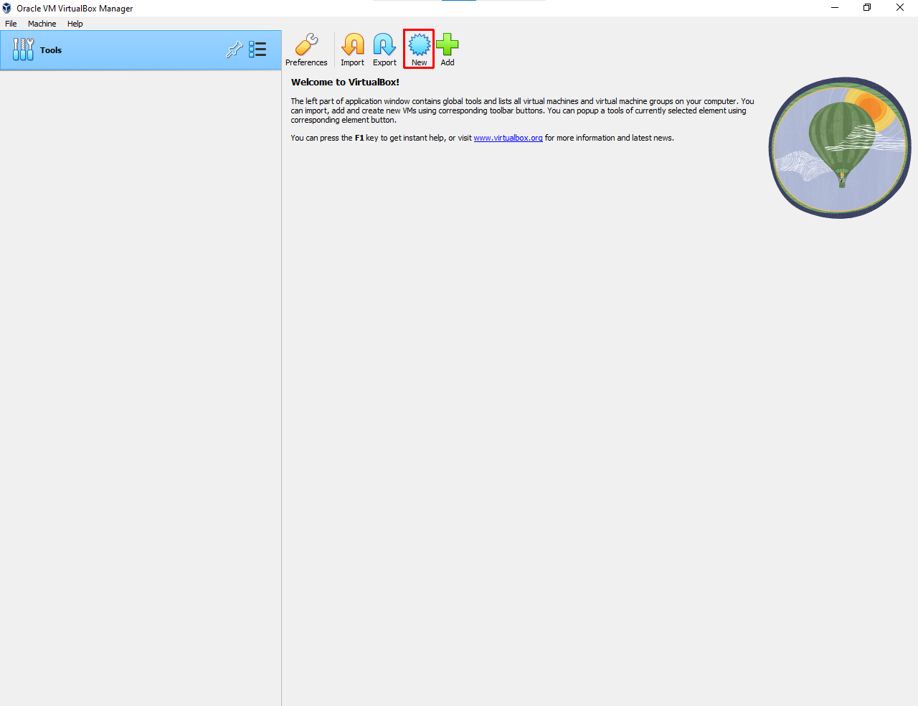

1. Enter your VM name and select Ubuntu OS ISO file, select Type Linux, Select Version Ubuntu (64-bit) and then click “Next”.

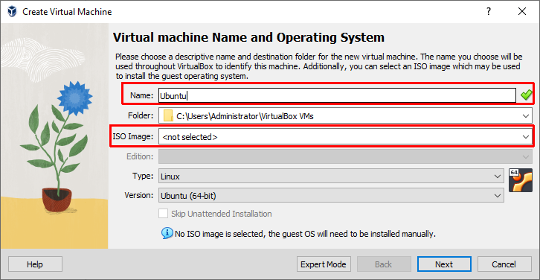

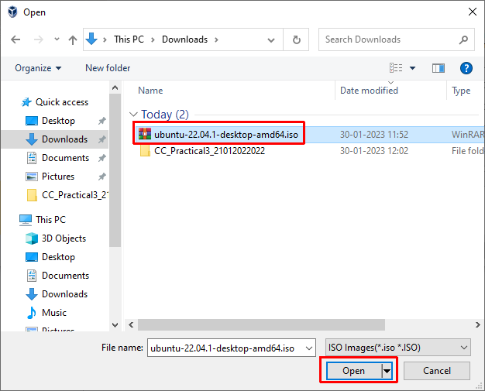

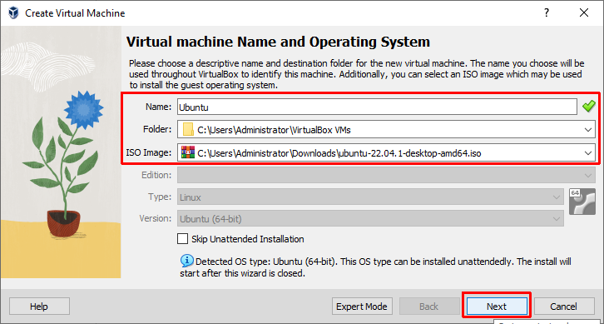

1. Select RAM size and Processors for VM Ubuntu OS then click “Next”.

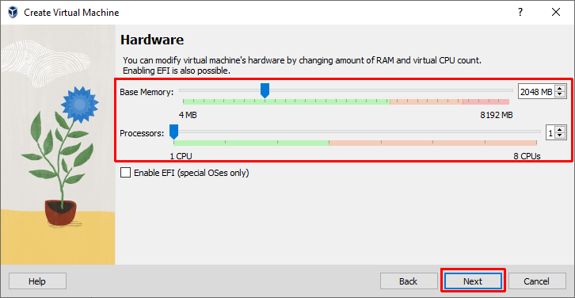

1. Select Storage space for VM Ubuntu OS as per need the click “Next”.

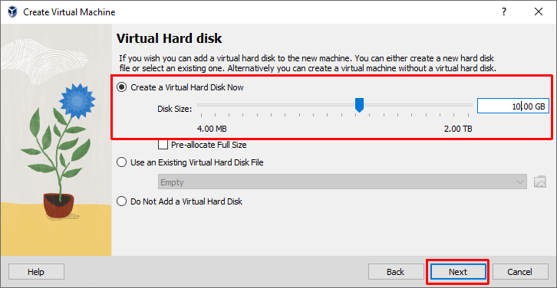

1. You can see VM Ubuntu OS configuration summary if you agree with this click “Finish” otherwise go back and made changes according to your requirement.

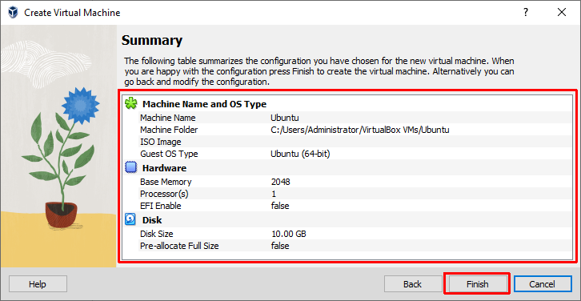

11) After following above steps you can see your VM Ubuntu OS at left of the virtual box. After that start VM OS.

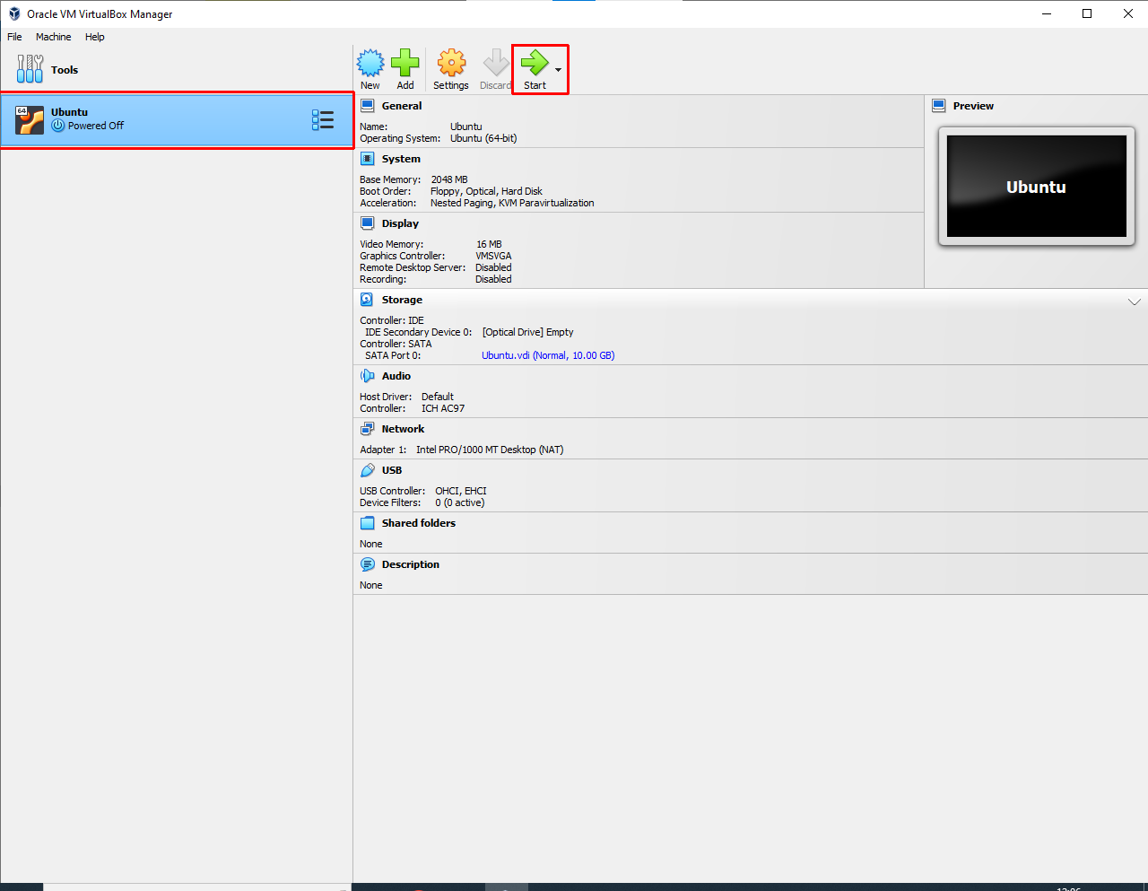

1. If we get this type error don’t worries just reselect your Ubuntu OS ISO file and click “Mount and Retry Boot”.

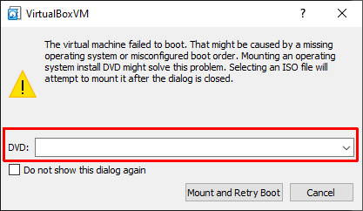

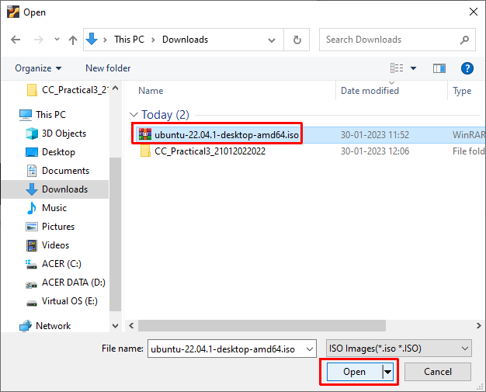

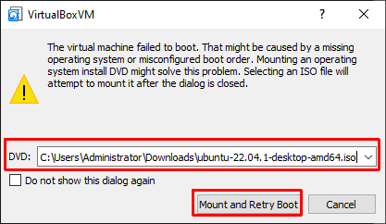

1. Select Try or Install Ubuntu.

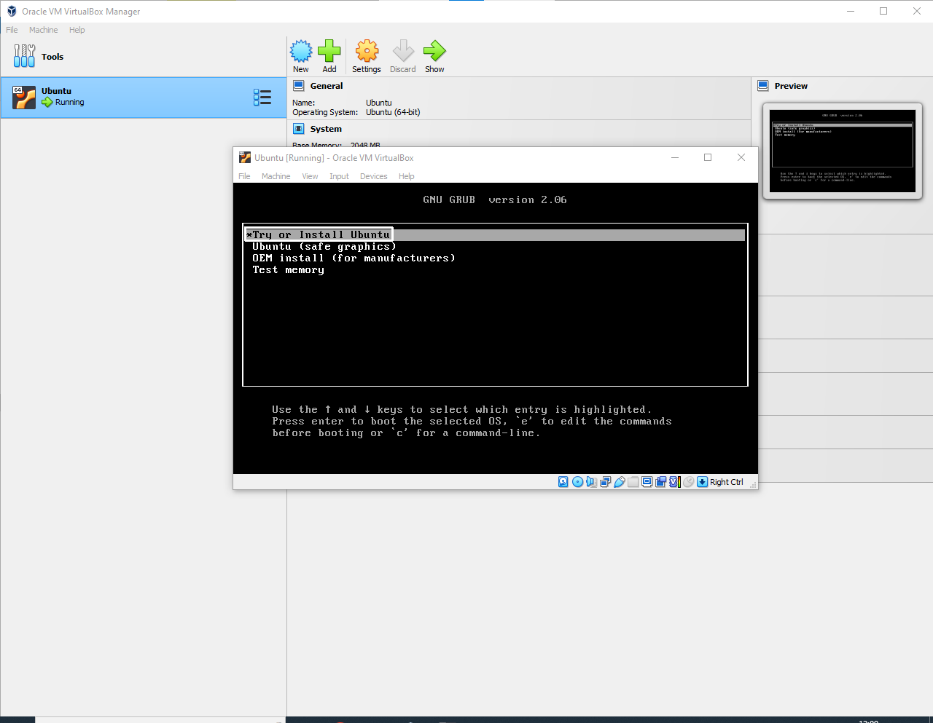

1. Select your language and click “Install Ubuntu”. If you need to use Ubuntu before installation click “Try Ubuntu”

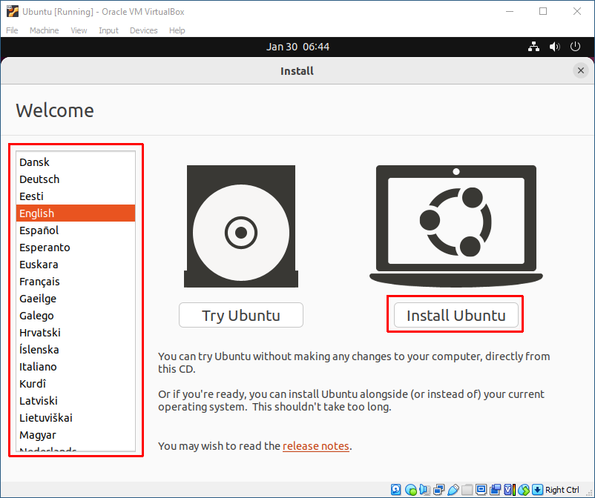

1. Select your keyboard language and click “Continue”.

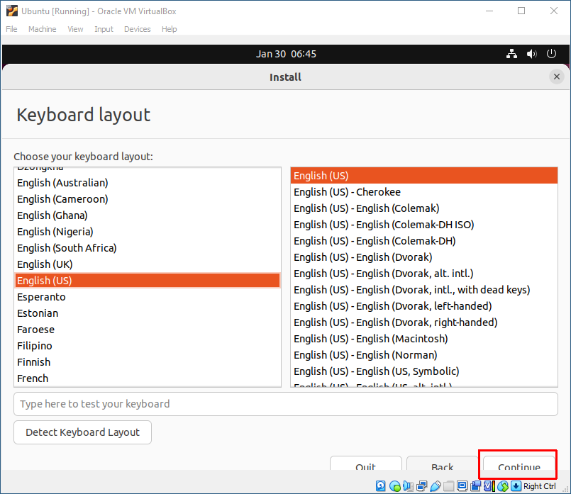

1. Select “Normal installation”, “Download updates while installing Ubuntu” then click “Continue”.

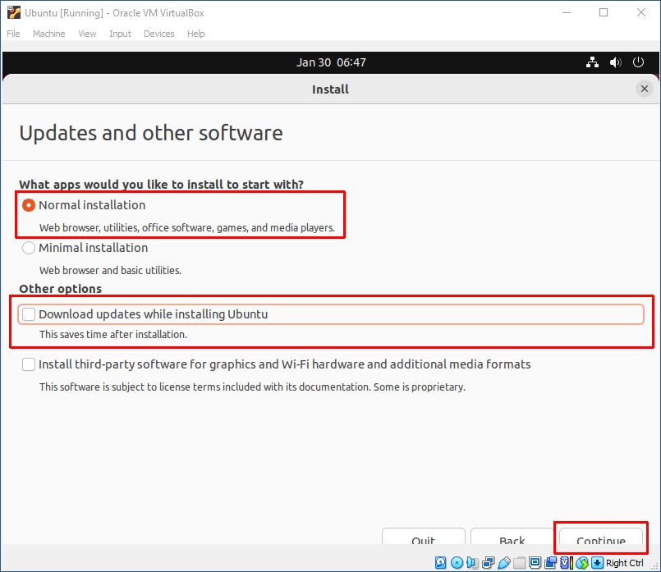

1. Select “Erase disk and install Ubuntu” then click “Install Now”.

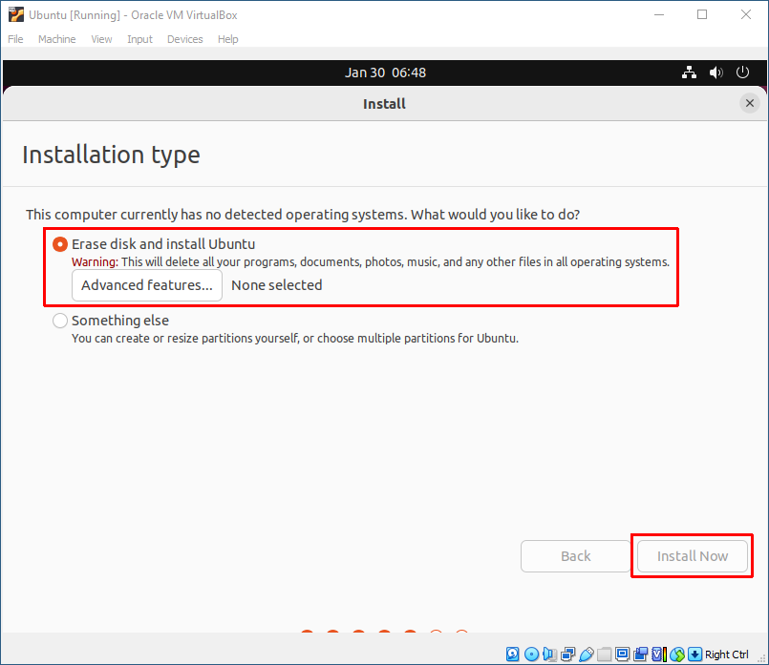

1. Select your location then click “Continue”.

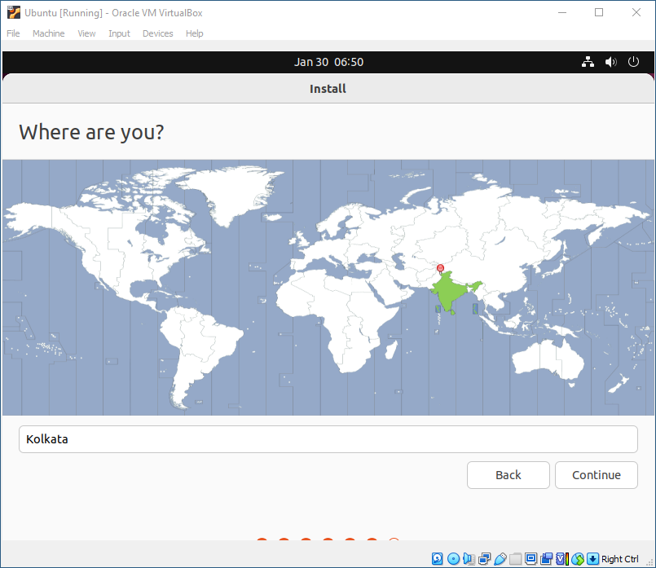

1. Enter details then click “Continue” and wait until installation is finish.

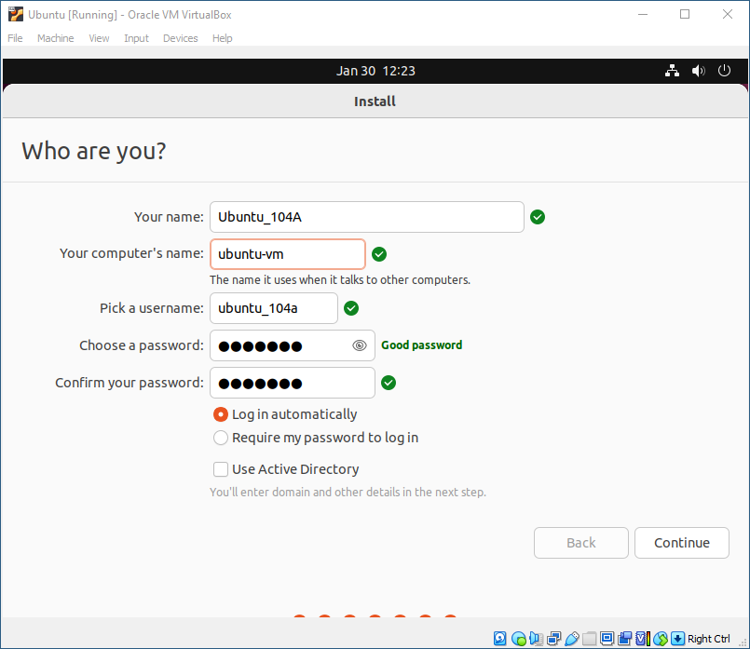

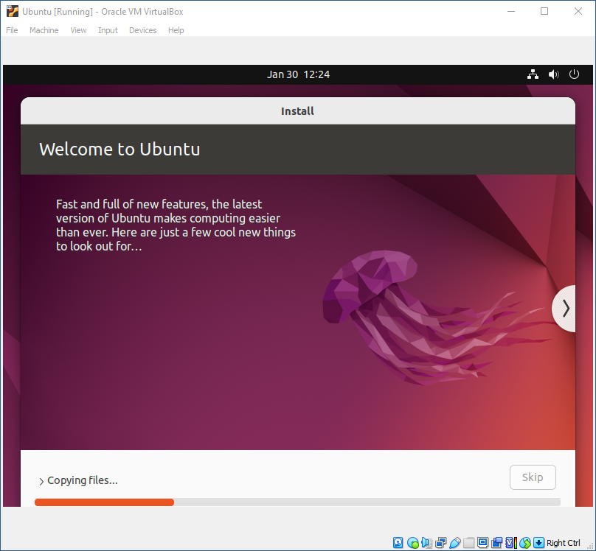

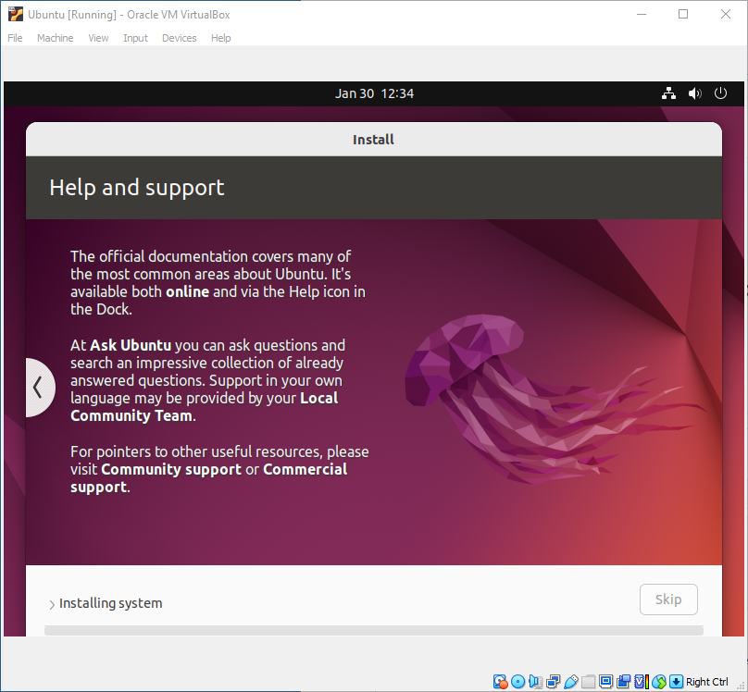

After installation is complete restart your virtual box then select your Ubuntu OS that available at left side of virtual box and start it.